Github action lab

GitHub Actions "Hello World" Workshop
Prerequisites
- A GitHub account
- A GitHub repository (or you'll create one)
Workshop Steps
Step 1: Create a New Repository
- Go to GitHub.com and sign in
- Click the "+" icon in the top right, then "New repository"
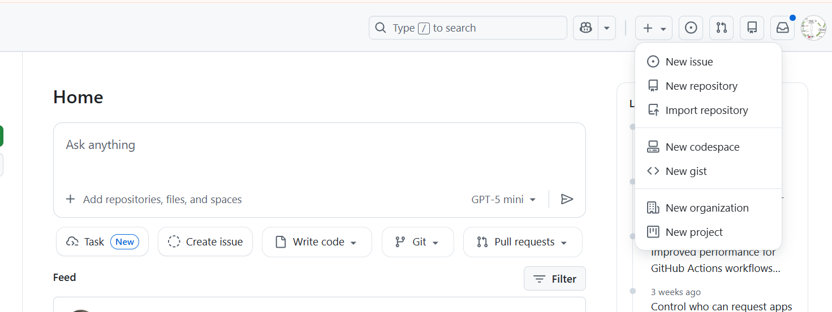
- Name it github-actions-demo
- Select "Public" and check "Add a README file"
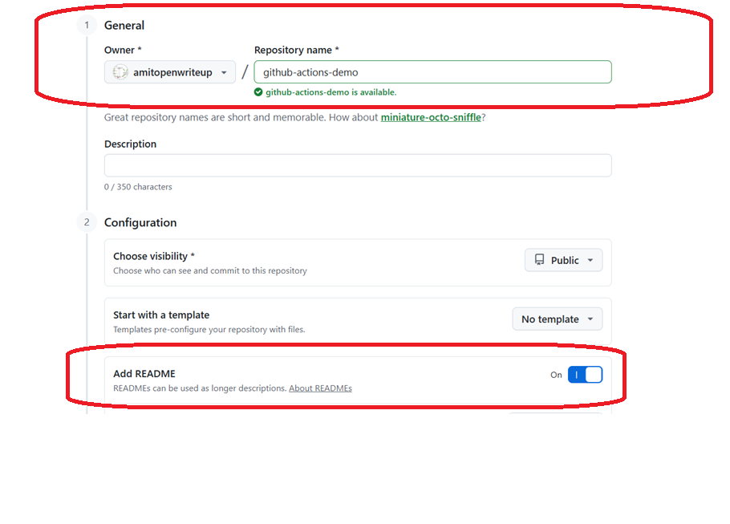
- Click "Create repository"
Step 2: Create Your First Workflow File
- In your repository, click "Add file" → "Create new file"
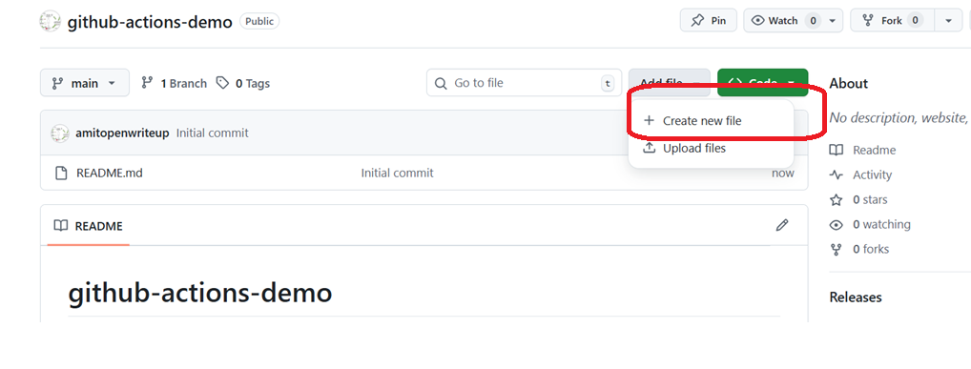
- Name your file: .github/workflows/hello-world.yml
  - The .github/workflows/ directory is where GitHub looks for workflow files
- Paste the following workflow code:
name: Hello World Workflow

on:
push:
branches:
- main
pull_request:
branches:
- main
workflow_dispatch:

jobs:
greet:
runs-on: ubuntu-latest

steps:
- name: Checkout code
uses: actions/checkout@v4

- name: Say Hello
run: echo "Hello, World! This is my first GitHub Action!"

- name: Print date and time
run: date

- name: Show current directory
run: pwd

- name: List files
run: ls -la
- Click "Commit changes"
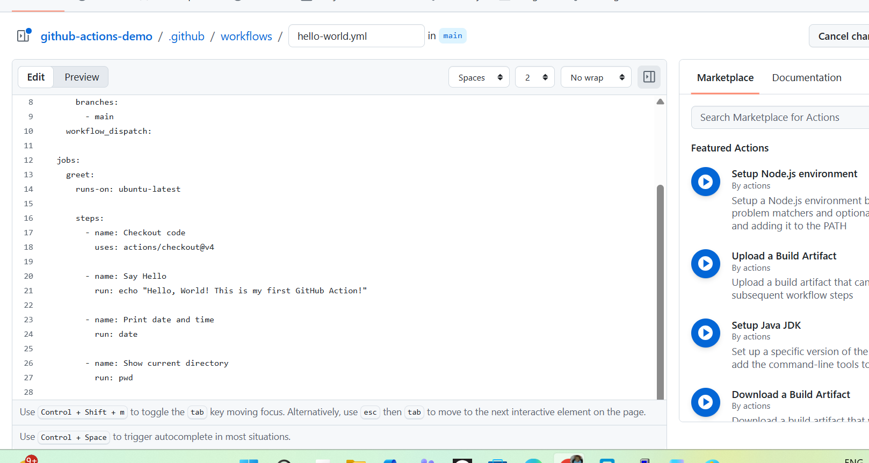
- Add a commit message like "Add hello world workflow"
- Click "Commit changes" again
Step 3: View Your Workflow Run
- Go to the "Actions" tab in your repository
- You should see your "Hello World Workflow" running or completed
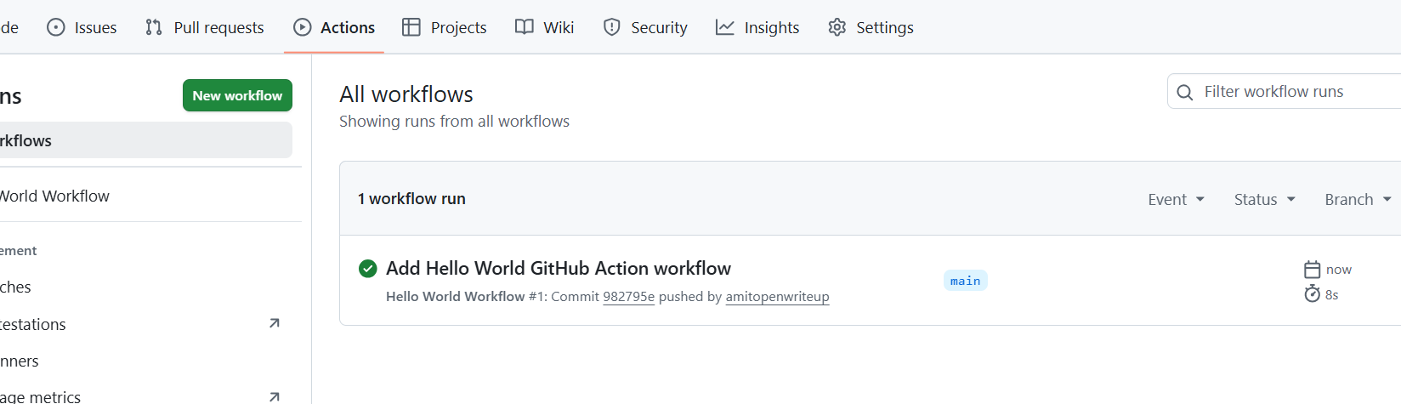
- Click on the workflow run to see details
- Click on the "greet" job to see each step's output
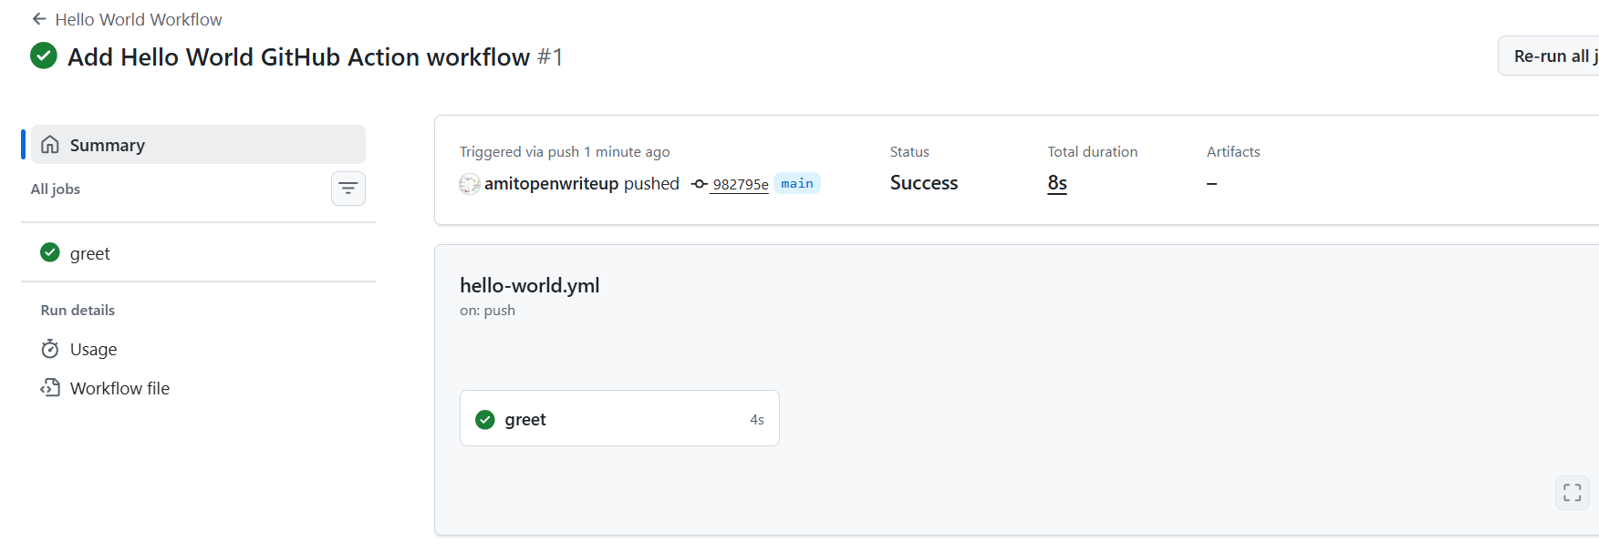
Step 4: Trigger the Workflow Manually
- Go to the "Actions" tab
- Click on "Hello World Workflow" in the left sidebar
- Click "Run workflow" button
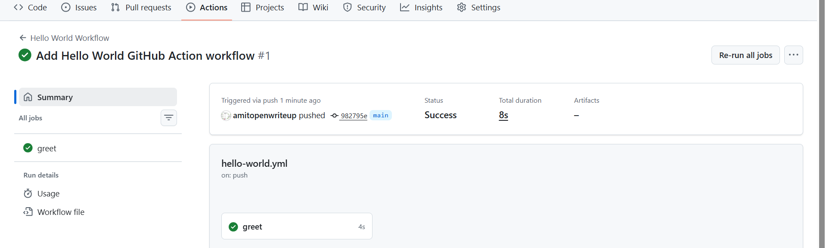

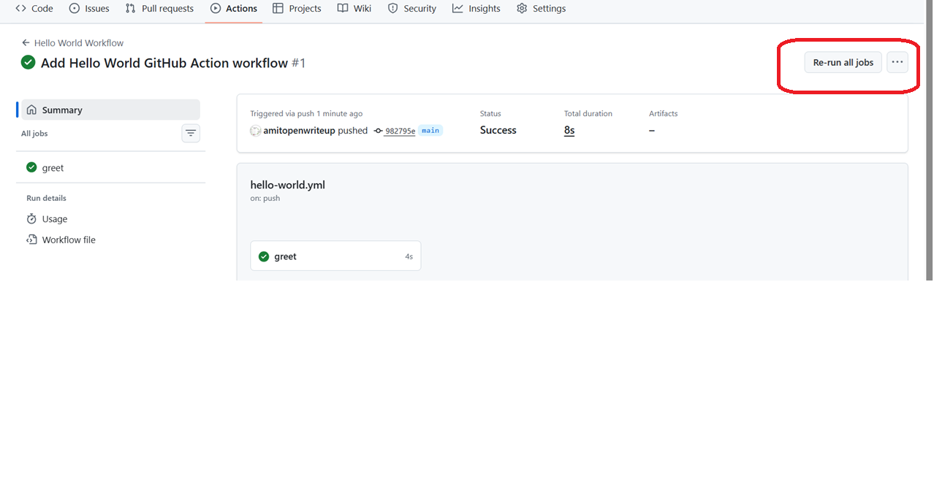
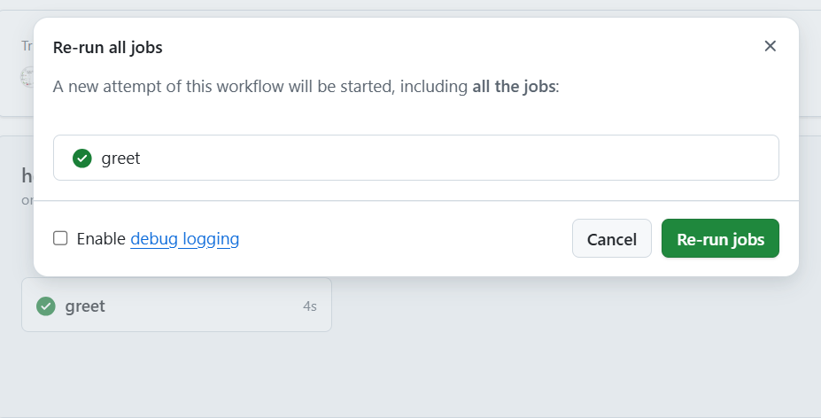

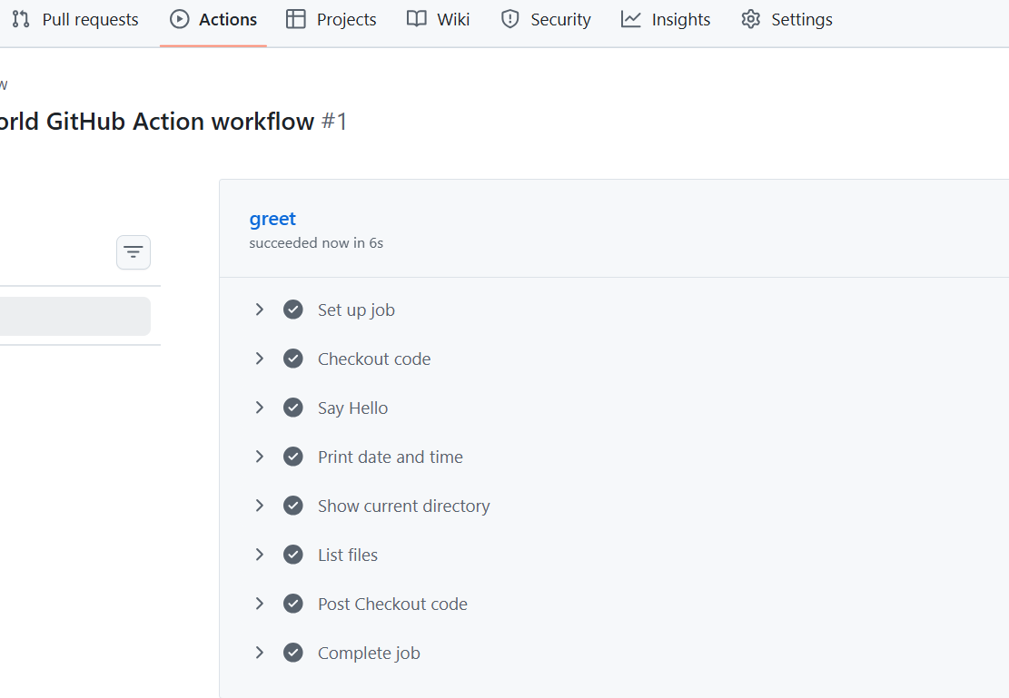
Understanding the Workflow
Workflow Components Explained
name: - The name that appears in the Actions tab
on: - Defines when the workflow runs:
- push: - Runs when code is pushed to main branch
- pull_request: - Runs when a pull request is opened/updated
- workflow_dispatch: - Allows manual triggering from the Actions tab
jobs: - Contains one or more jobs that run in the workflow
runs-on: - Specifies the runner environment (ubuntu-latest, windows-latest, macos-latest)
steps: - Individual tasks that run sequentially:
- uses: - Uses a pre-built action (like checkout)
- run: - Runs a shell command

